Art Bible

A Way Out!

*Example*

*Remember: the use of pictures are great in design documents. They are great as a reference material, they really get your point across and they make the document itself generally look better.*

*Everything in BLUE and any pictures feel free to delete and use the rest as a template for your own game design document.*

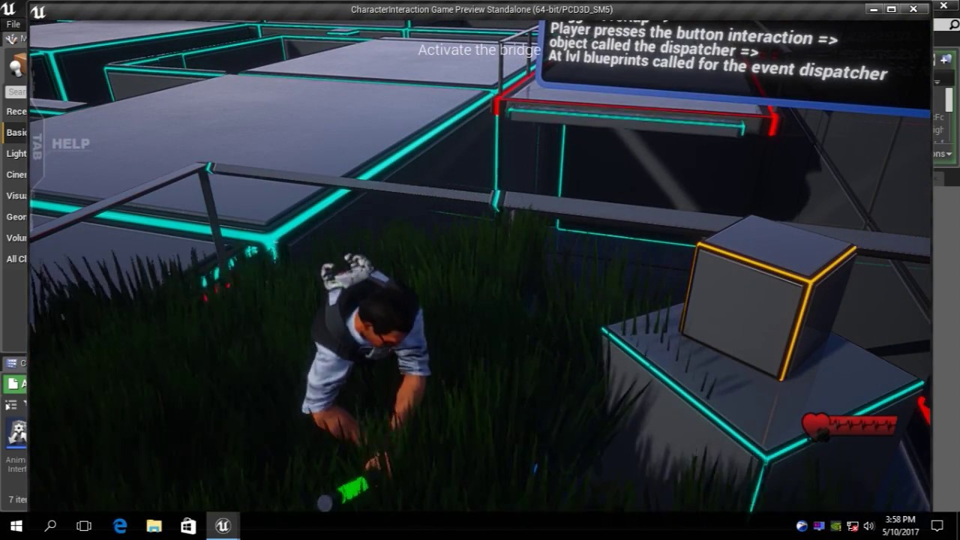

Short Story/Description

What your game is about?

*You really only need a short amount of information for this part. It is only to set the scene and give the reader an idea of how the game is going to feel. Keep this to a minimum, it really doesn’t need to be complex.*

In a modern robot factory located in the city, where futuristic robots are being build. A robot named Hal-09 wants to escape the factory which has the highest security in the world. Hal-09 must escape the high security factory using the tools that can be found inside the building.

What is the setting of the game? (E.g. Location, time and theme.)

*Feel free to write a sentence or just a few dot points.*

Robot factory

Futuristic

Modern interior

Time: 2020

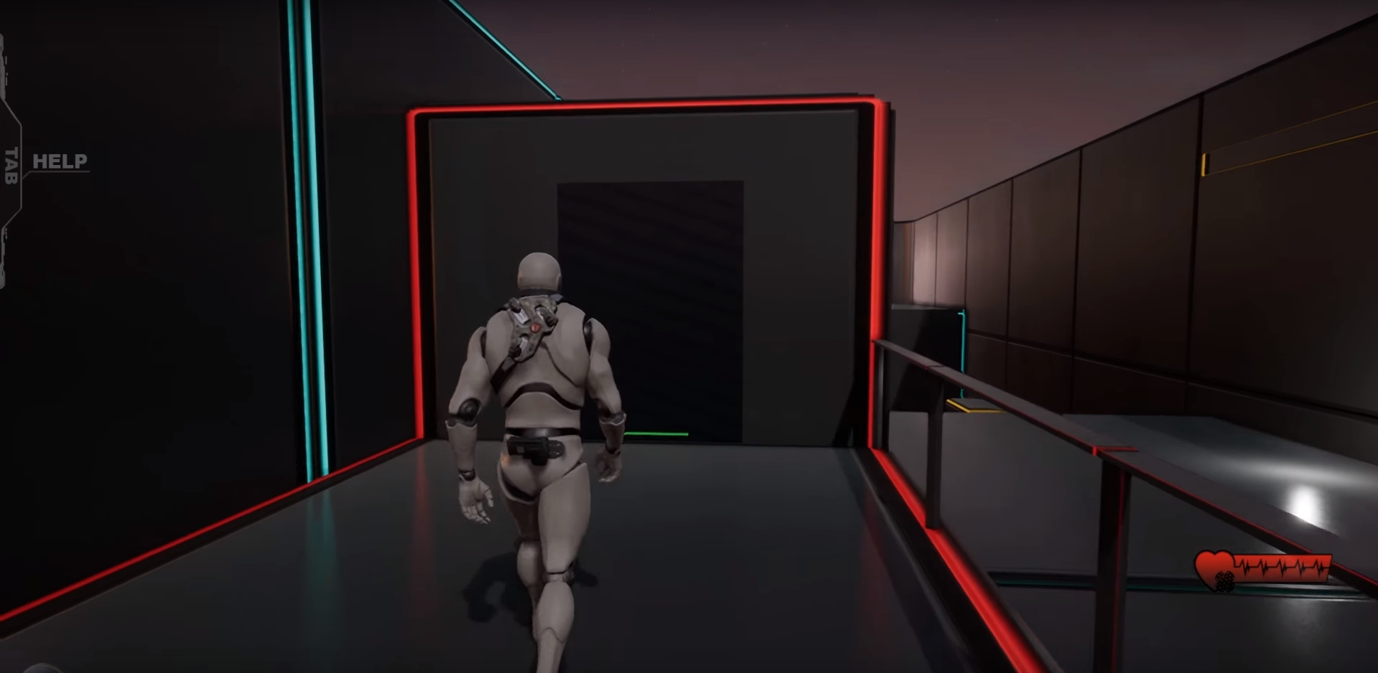

Futuristic building interior – (3d game animation, 2017)

Art Style

How is your game going to look?

*For this you are going to have to source some reference images. What you’re looking for in these images is things like theming, colour pallet, any objects that you like the look of that you think would fit your theme. Really just get anything you think would fit in your game. Then write up a short sentence describing your art style.*

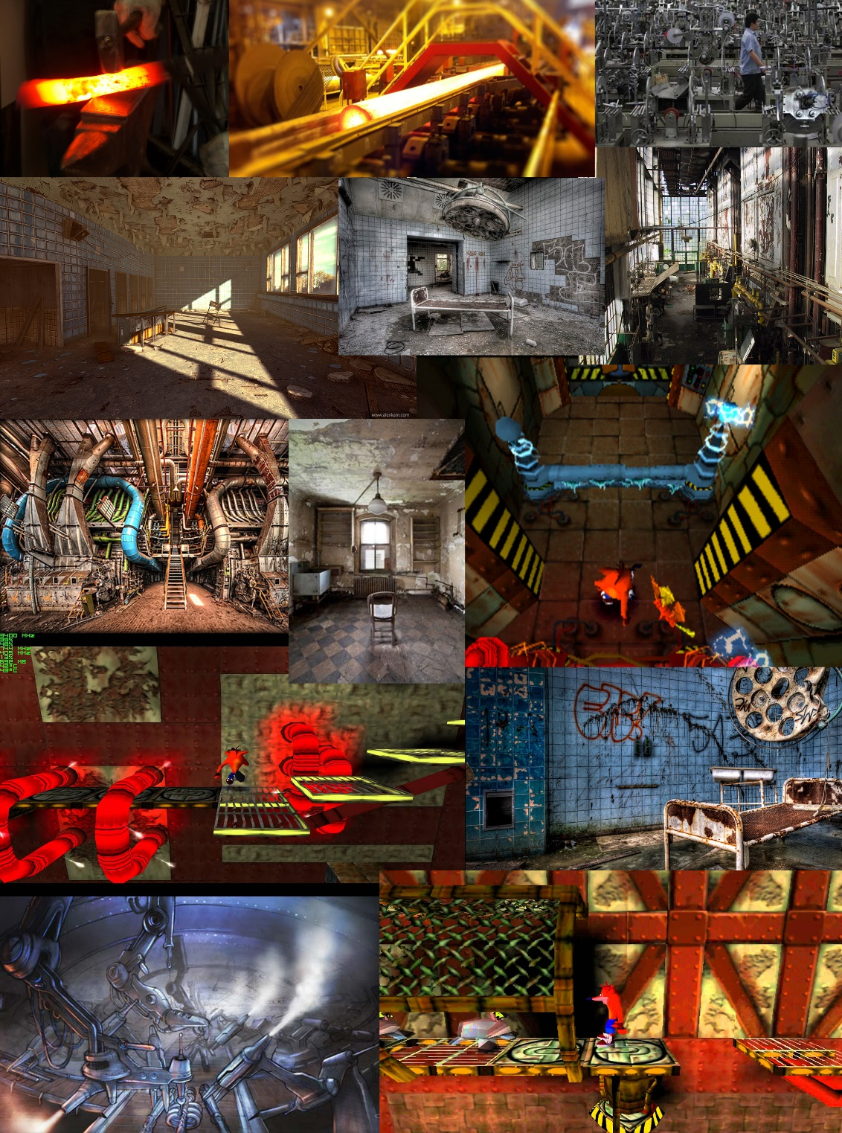The art style for Don’t believe the pipe as you can see is very influenced by crash bandicoot’s heavy machinery and Cortex Power levels so I’m going for a very industrial look whilst also keeping it very rundown and poorly looked after.

Puzzles and Mechanics

How is your game going to play?

*Create a list of all mechanics and puzzles. You should have a few more that the example content.*

Mechanics:

Elevator

Simple moving platforms that move from A to B and back again.

Unlockable door

Player has to find a key or a card to unlock the door

Security Cameras:

Player has to avoid security cameras if you get caught mission will be restarted.

Patrolling guards

Guard patrols on from point A to B, player need to avoid getting on sight of guards

Key Assets

What objects are going into your game?

*A list of the models that you are going to create with a short description of what they are.*

Robot (Hal-09)

A player character Hal-09, it’s a small character has head, hands and legs.

Platforms

The Platforms are a section of grating being held up with the use of futuristic technology

Security cameras

Security cameras with the red light.

Interior building

Modern interior, clean black, blue and dark tile background. The player is going to see the most of this so a little more time needs to be spent on it.

Doors

Doors with the keypad and normal door which can be unlocked using key or password.

Asset list and schedule

*When it comes to coming up with how long it’s going to model and texture all your objects it is rather difficult to know how long it’s going to take to do, especially if you’re new to 3D.*

***Don’t stress and just estimate the times.***

*If you feel like one of your assets is more complex than others then assign more time. Once your skill level improves you can make more educated guesses as to how long things are going to take. For example I know that my models are going to be pretty simplistic and most of the detail is going to come out in the texturing, so I’ve assigned more time in those areas to a point that I feel is appropriate. Same thing with the mechanics. Just estimate the times.*

|  |  |  |  |
| --- | --- | --- | --- |
| Asset/ Mechanic |  | Time to build | Time to texture |
| Asset | Robot | 5 Hours | 2 hour |
| Asset | Elevator | 1 hour | 20 min |
| Asset | Interior building | 5 hours | 3 hours |
| Asset | Security cameras | 2 hour | 20 minutes |
| Mechanic | Unlockable door | 3 hour |  |
| Mechanic | Guard | 6 hour |  |